

REPORT FILE

NAME: Nachiket Gadge

REG-NO.: 25BCE10852

BRANCH: Computer Science and Engineering (CORE)

YEAR: 2025 – 2029

COURSE CODE: CSE0001

SUBJECT: Digital Literacy

Introduction
The rapid evolution of the digital landscape has made digital literacy an essential skill for modern engineering students. This project is developed within the framework of the CSE0001: Digital Literacy course at VIT Bhopal University, where I have been appointed to the role of a Student Digital Ambassador. The primary objective of this role is to assist my peers in navigating the complexities of the digital world—ranging from building professional online identities to ensuring safe and responsible communication practices.
This portfolio serves as a comprehensive record of my transition from a general user to a digitally literate professional. Organized into five distinct modules, the project documents my work in visual communication, professional networking, cloud-based collaboration, email etiquette, and cybercrime awareness. By utilizing various browser-based tools and platforms, I have built a foundation that will support my academic journey and my future career in the technology sector.

Task 1: Digital Literacy Infographic
- Action: Create a one-page visual using Canva or Google Slides.
- Content: Cover at least 3 topics (e.g., safe internet practices, email etiquette, or digital tools).
- Report: Write 150–200 words on the tool used and your design process

For Task 1, I designed a Digital Literacy Awareness infographic using Canva. The visual resource is designed for my peers to understand the core pillars of being a Student Digital Ambassador. My design covers five key areas: a definition of digital literacy, essential tools like GitHub and Google Workspace, internet safety tips, the importance of a professional presence on LinkedIn, and basic email etiquette rules.
I found it particularly interesting to learn how to condense complex information into short, impactful bullet points that are easy for students to read quickly. One minor difficulty was choosing a color scheme that looked professional yet engaging. This task helped me realize that digital literacy is not just about using tools, but about using them responsibly and professionally to build a strong digital identity.

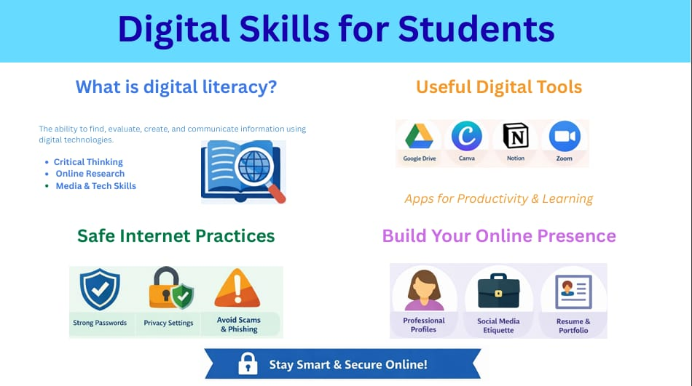

Task 2: Student Digital Portfolio
Action: Update or create accounts on GitHub, LinkedIn, and one other (Kaggle/Stack Overflow).
Specifics: On GitHub, create a "Profile README" (a repo named after your username) with your branch and year.
Report: Write 150–200 words explaining the purpose of each platform.

For Task 2, I established my professional digital presence by setting up and updating profiles on GitHub, LinkedIn, and Kaggle. I chose these three platforms because they represent the essential pillars of a modern computer science student’s portfolio. GitHub serves as a version control system where I can host my coding projects and collaborate with others. LinkedIn is my primary professional networking tool for connecting with industry experts and tracking internship opportunities. Kaggle provides a platform for me to practice data analysis and participate in competitive programming.
Over the next four years of my B.Tech at VIT Bhopal, I plan to use these tools strategically. I will use GitHub to document my progress in learning languages like Java and Python, making my code open-source for feedback. On LinkedIn, I will build a professional network to stay informed about technical trends and career paths. Finally, I will use Kaggle to apply my classroom knowledge to real-world datasets. Building these profiles early ensures that I have a documented history of my growth and skills by the time I apply for internships and placements.

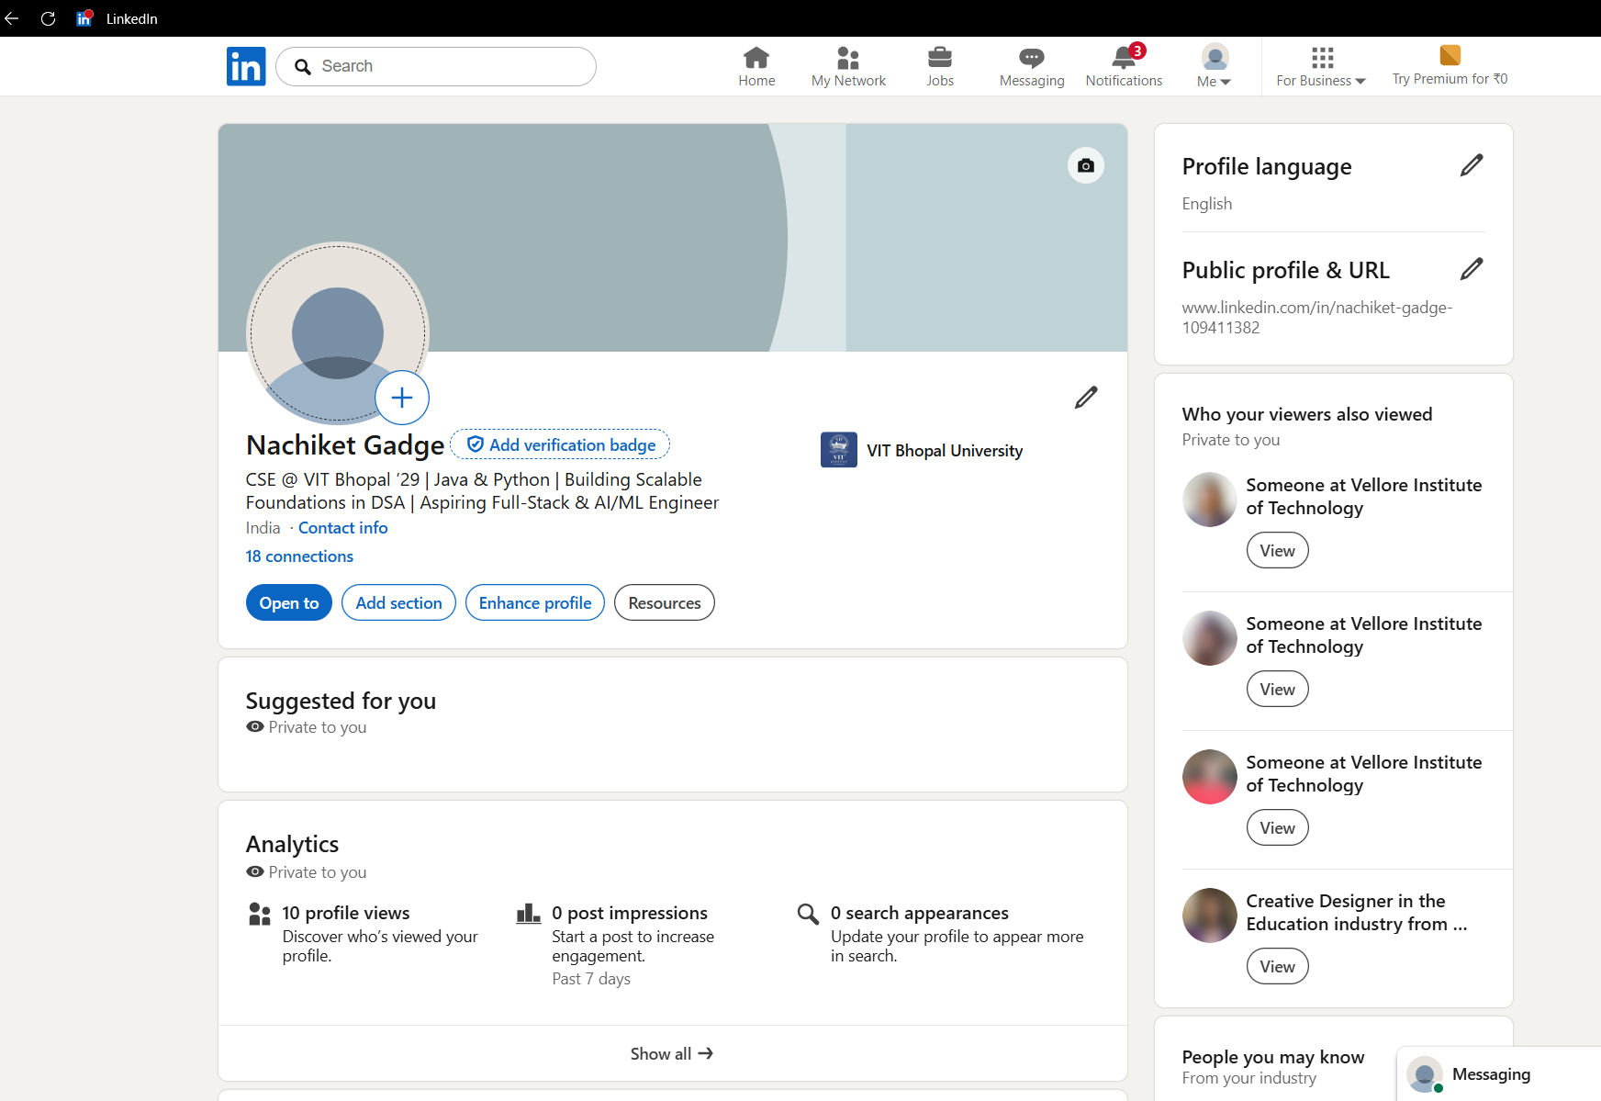

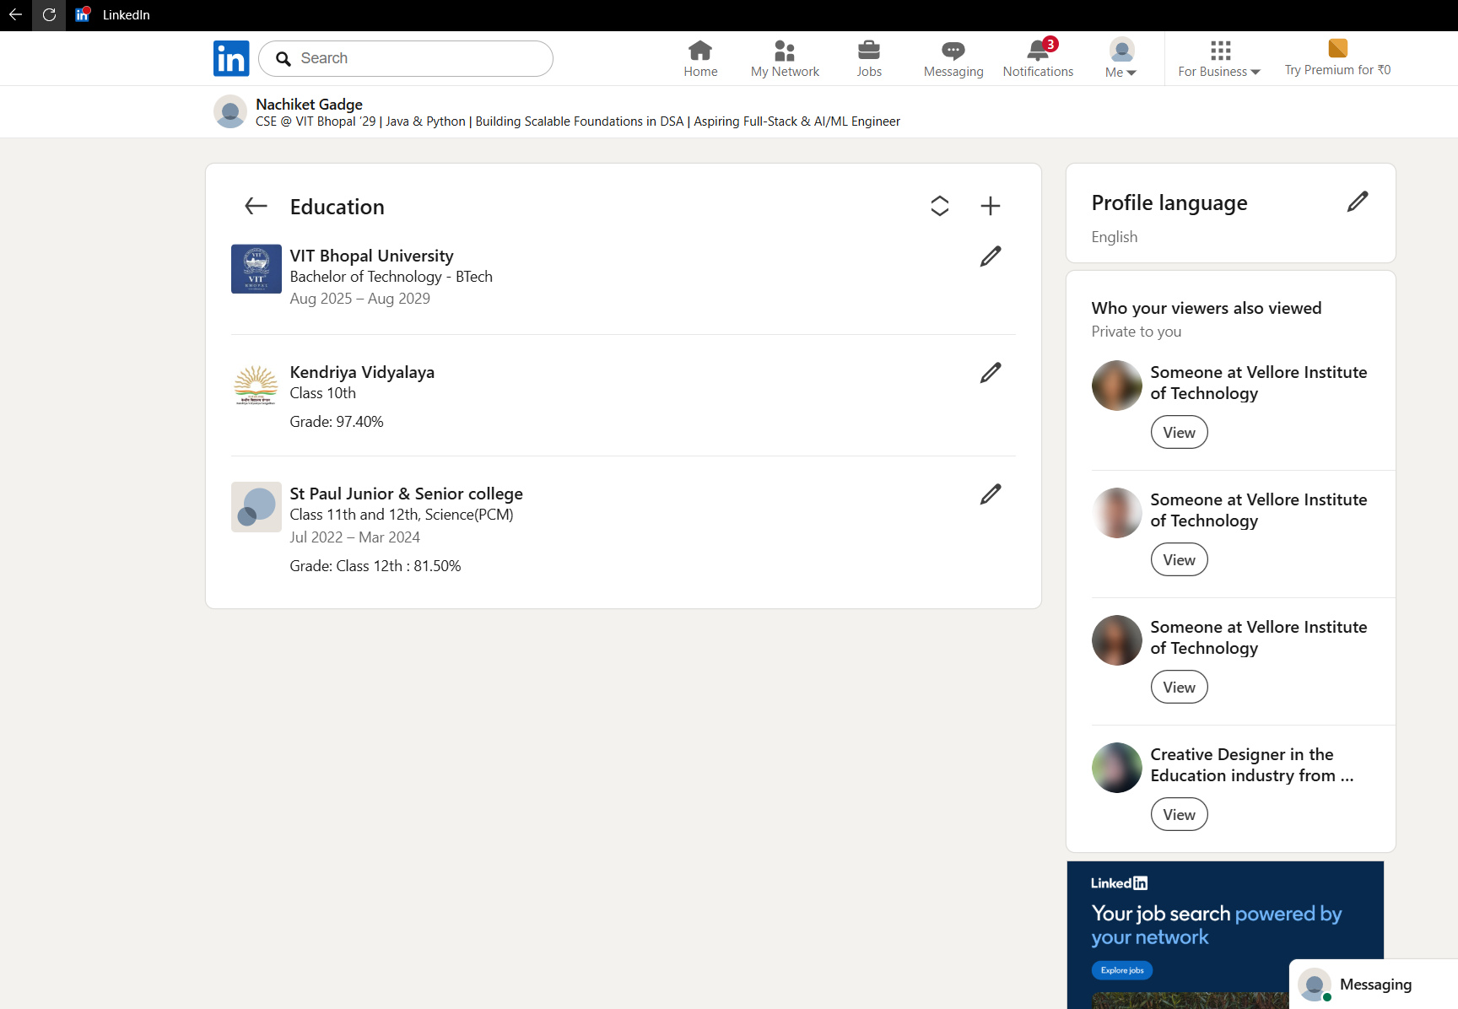

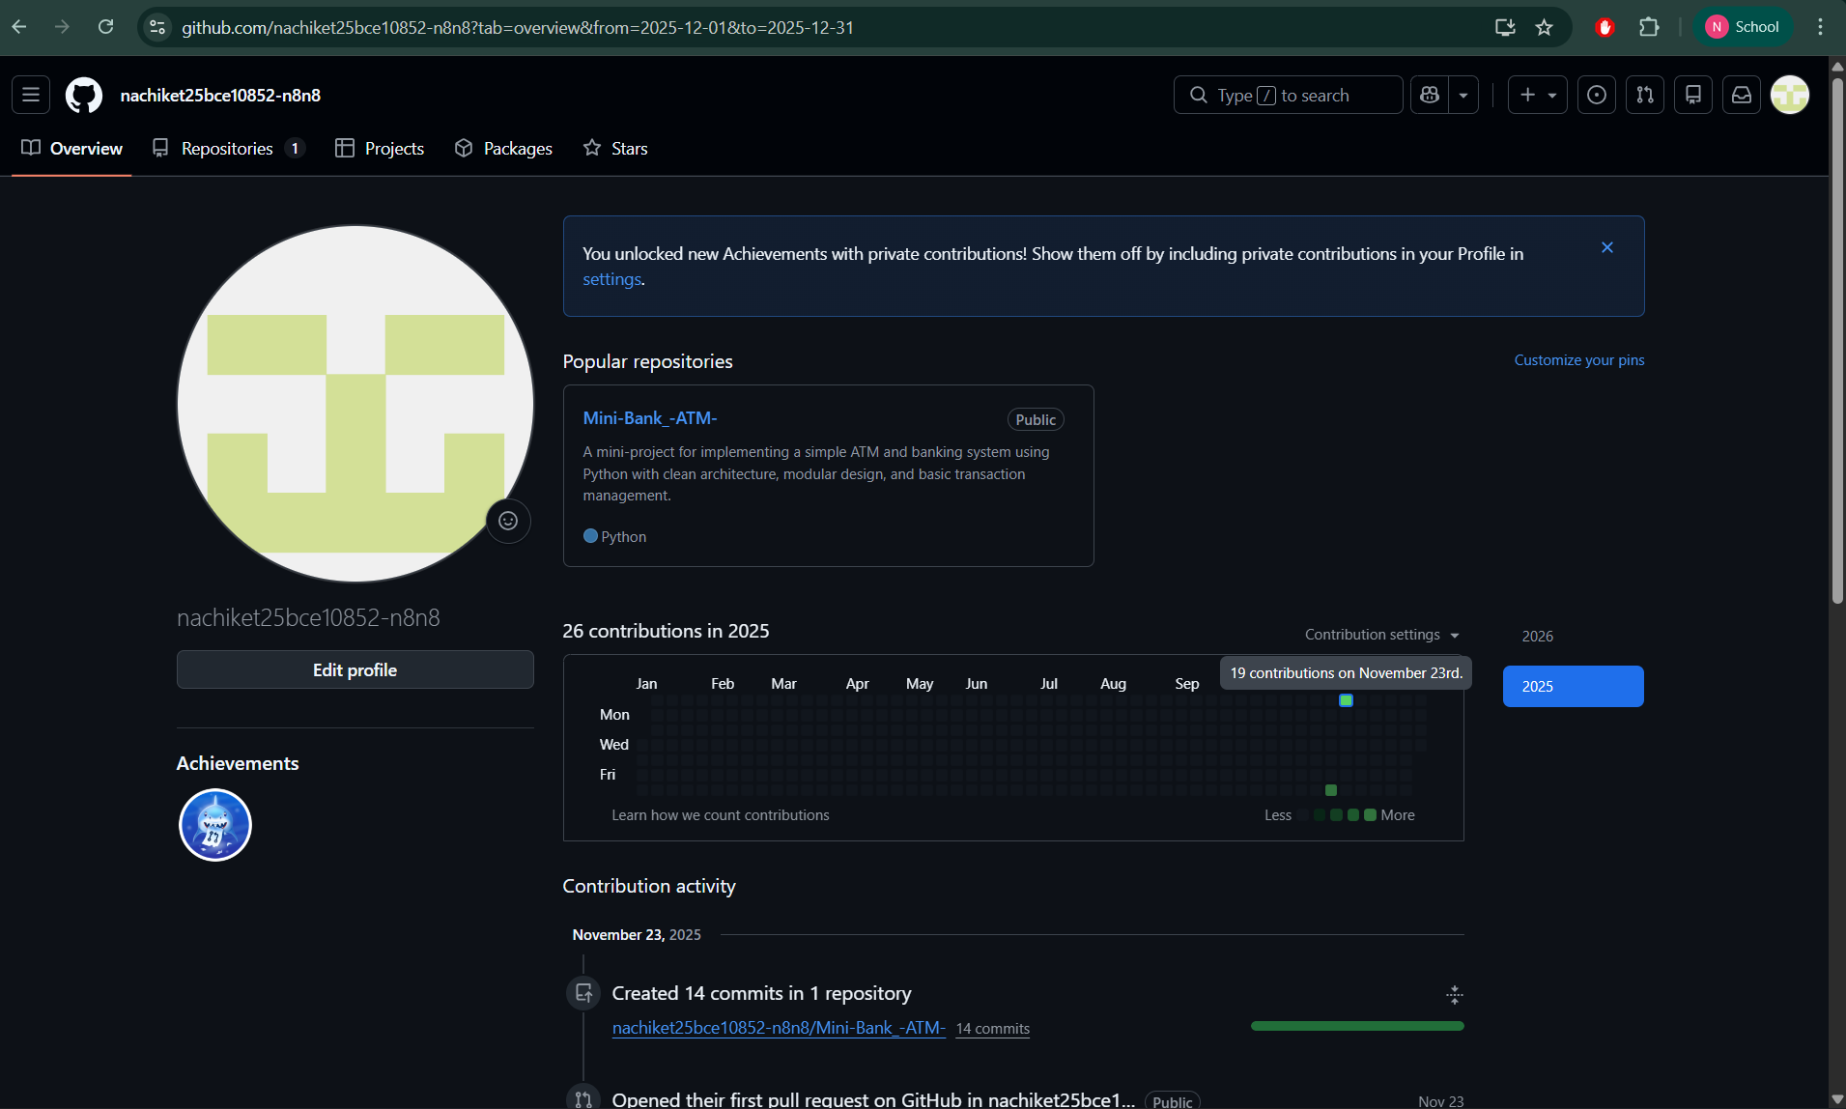

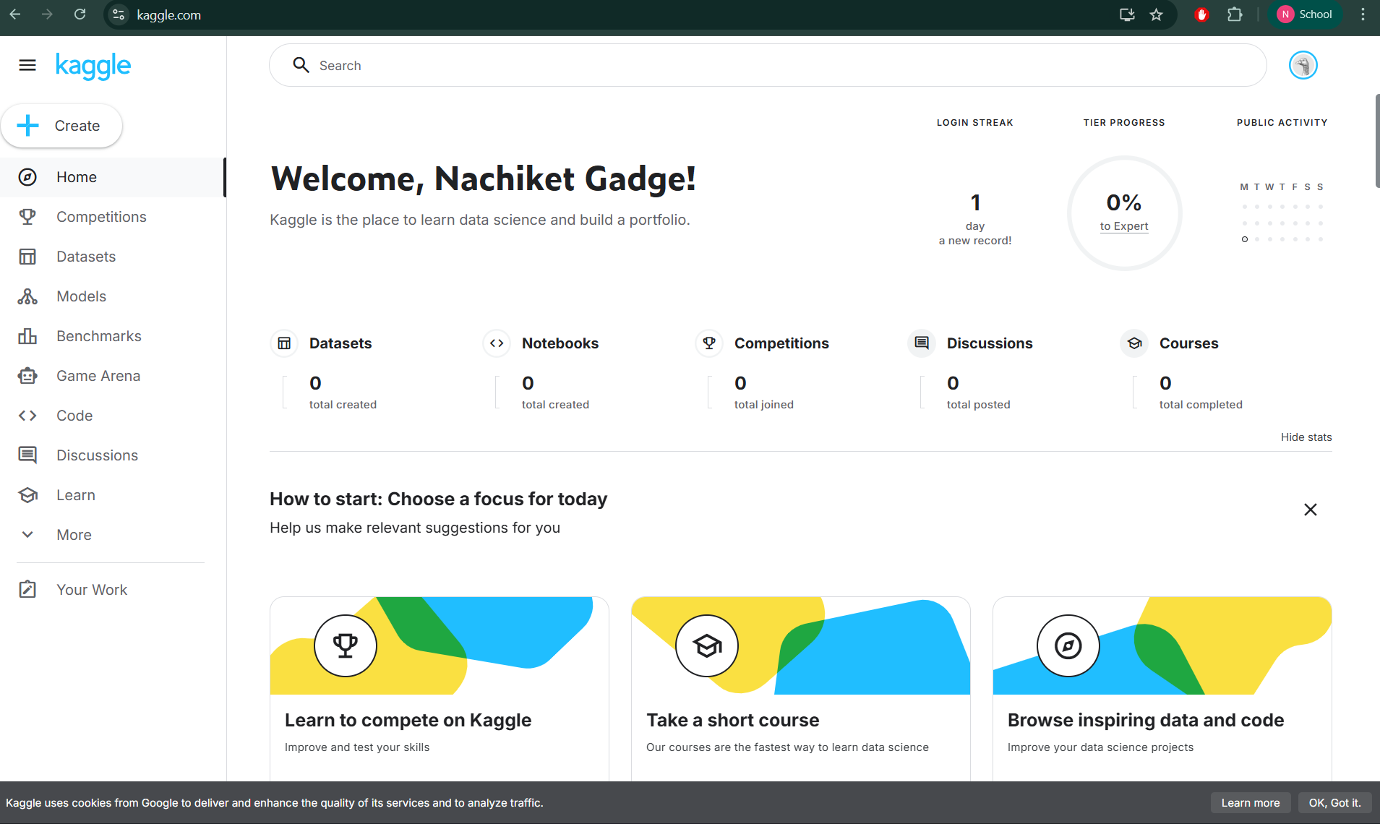

Task 3: Coding & Collaboration
Part A: Complete one beginner challenge on HackerRank or CodeChef (e.g., "Solve Me First").
Part B: Create a Google Form with 5 questions for a "Digital Literacy Quiz" and link it to a Google Sheet.
Report: Write 150–200 words on how these tools help you academically.

For Task 3, I explored platforms essential for technical skill development and cloud-based collaboration. In Part A, I used HackerRank to complete a beginner-level coding challenge. Solving this problem helped me practice syntax and logic in a timed environment, which is vital for technical interviews. These platforms allow me to track my progress and compare my problem-solving skills with a global community of developers.
In Part B, I utilized Google Forms to create a 'Digital Literacy Awareness Quiz' consisting of five targeted questions. I also linked the form to a Google Sheet to automate the collection of responses. This exercise demonstrated how cloud tools can be used to gather and analyze data efficiently. Academically, these tools are invaluable for conducting surveys for research projects and collaborating on group assignments in real-time. Mastering these platforms ensures that I can effectively manage both my individual coding practice and team-based academic responsibilities throughout my degree.

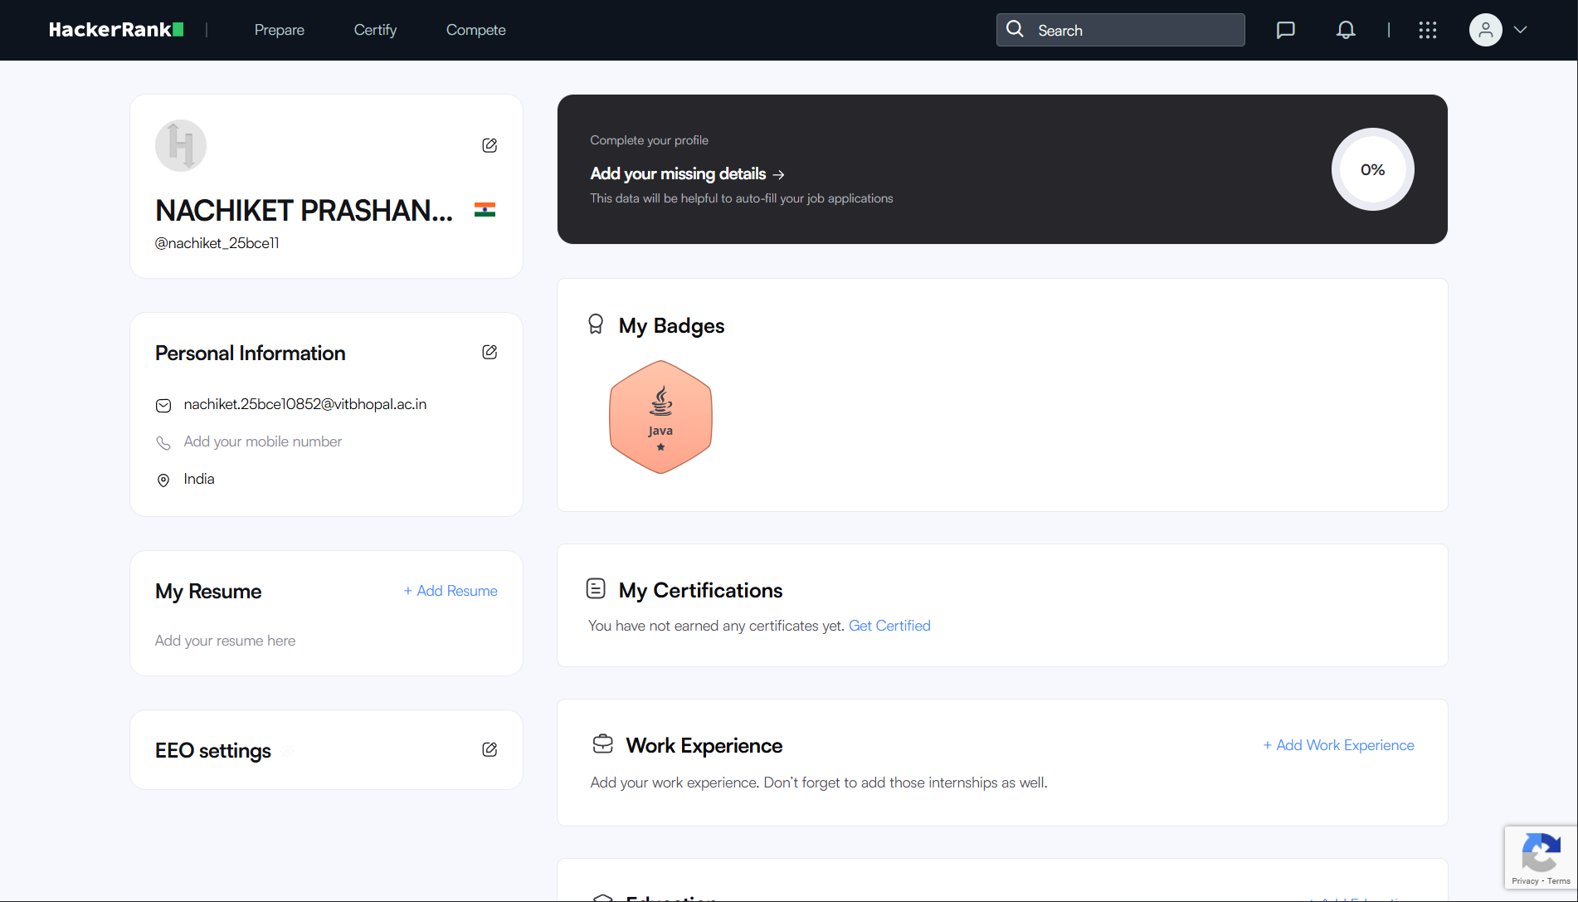

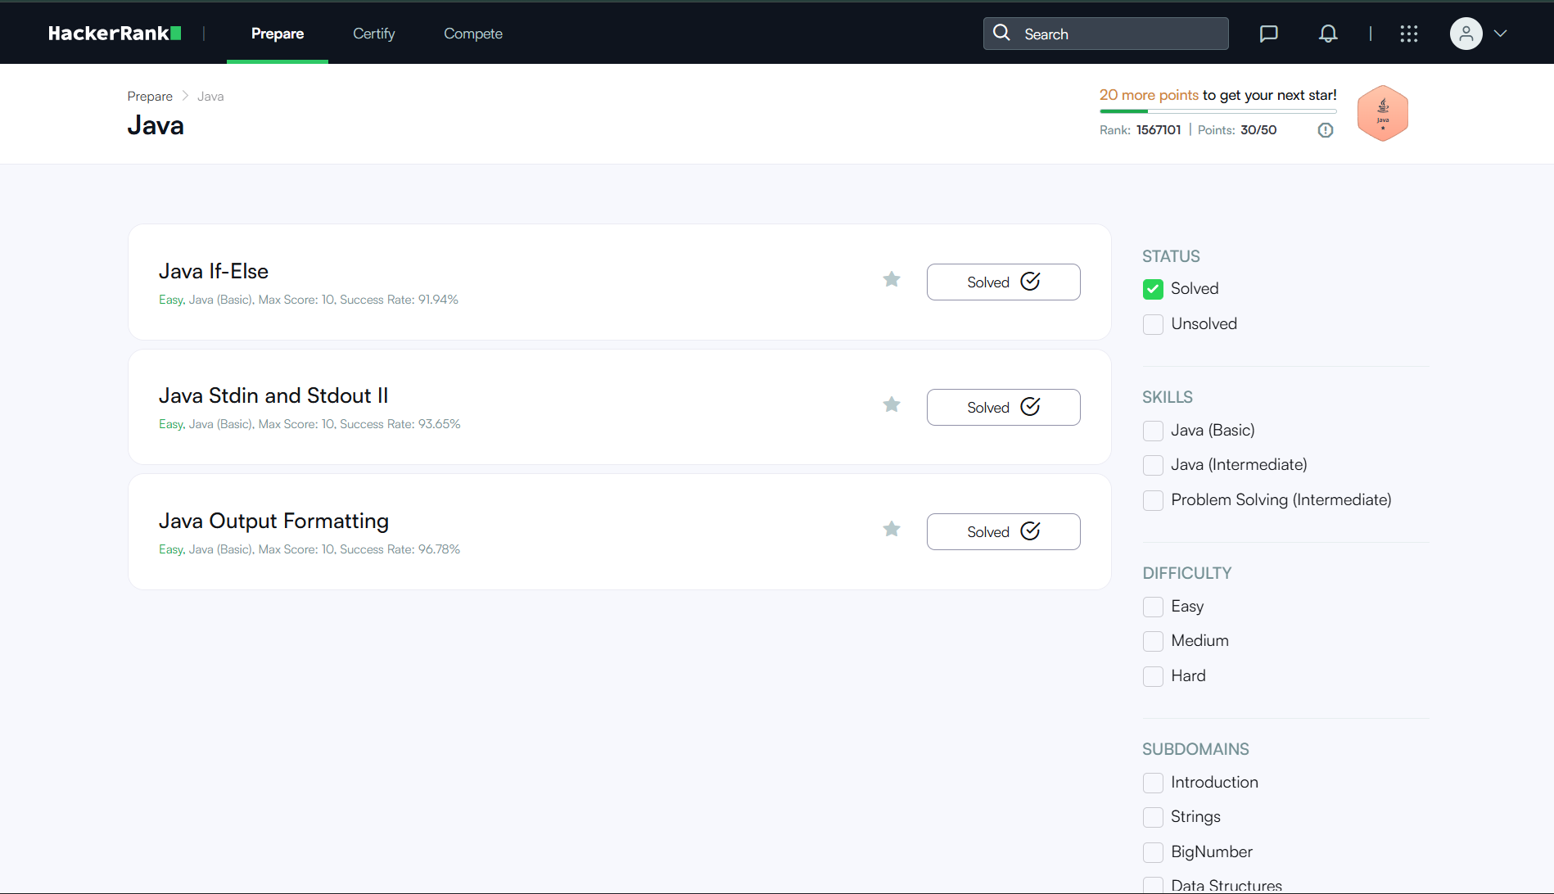

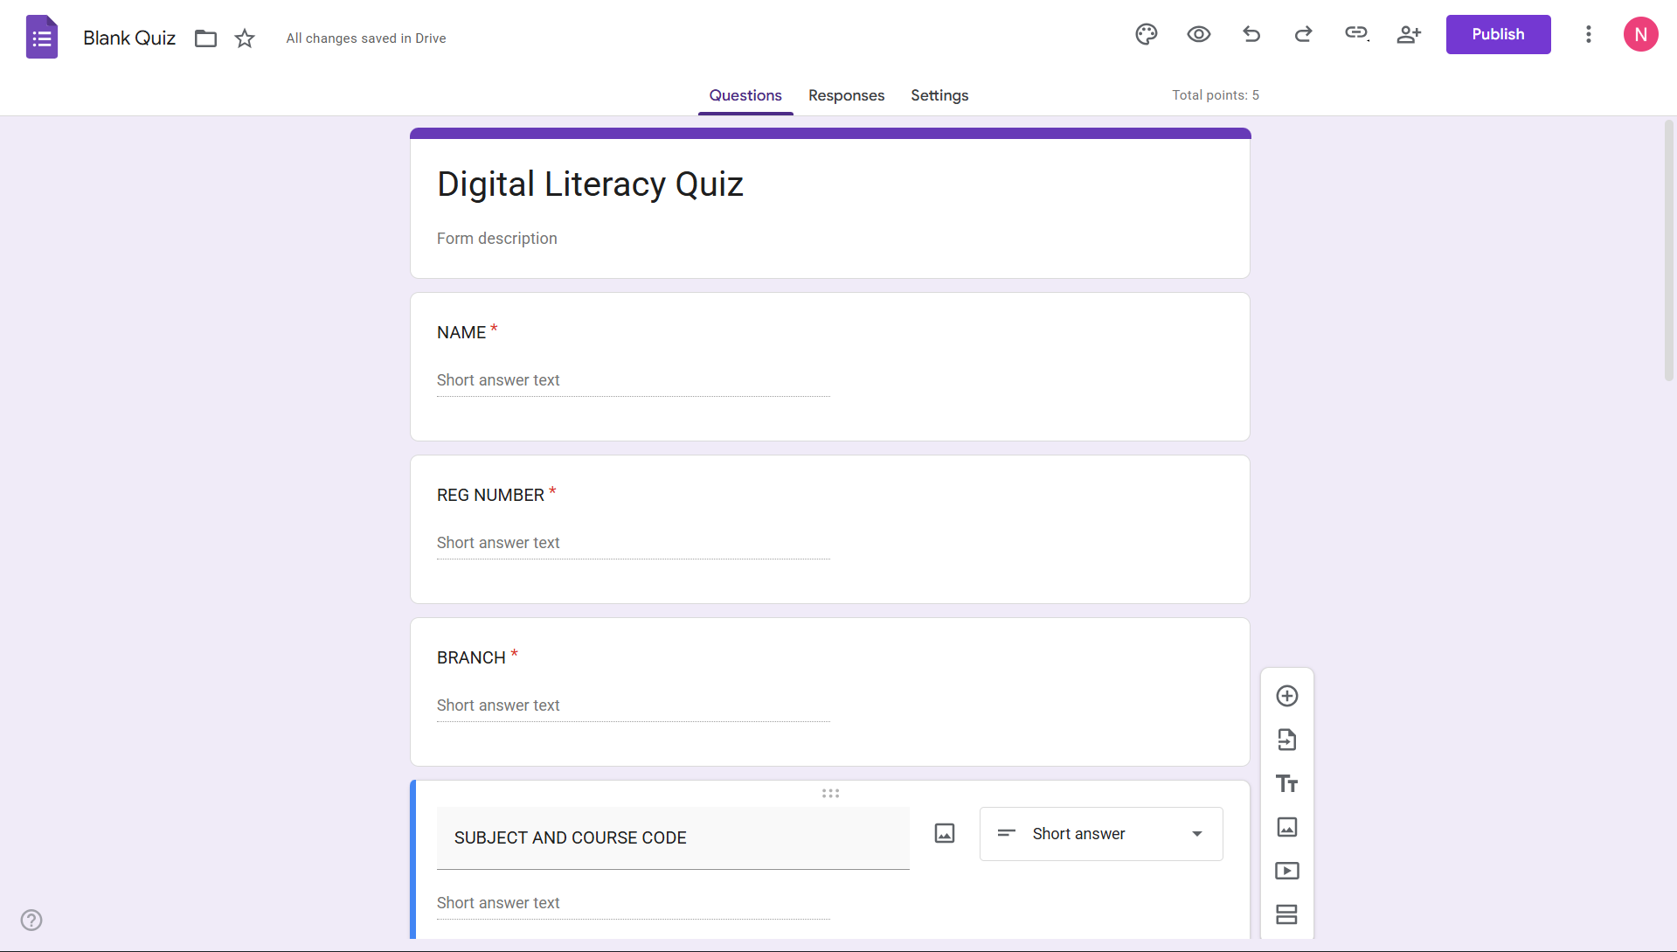

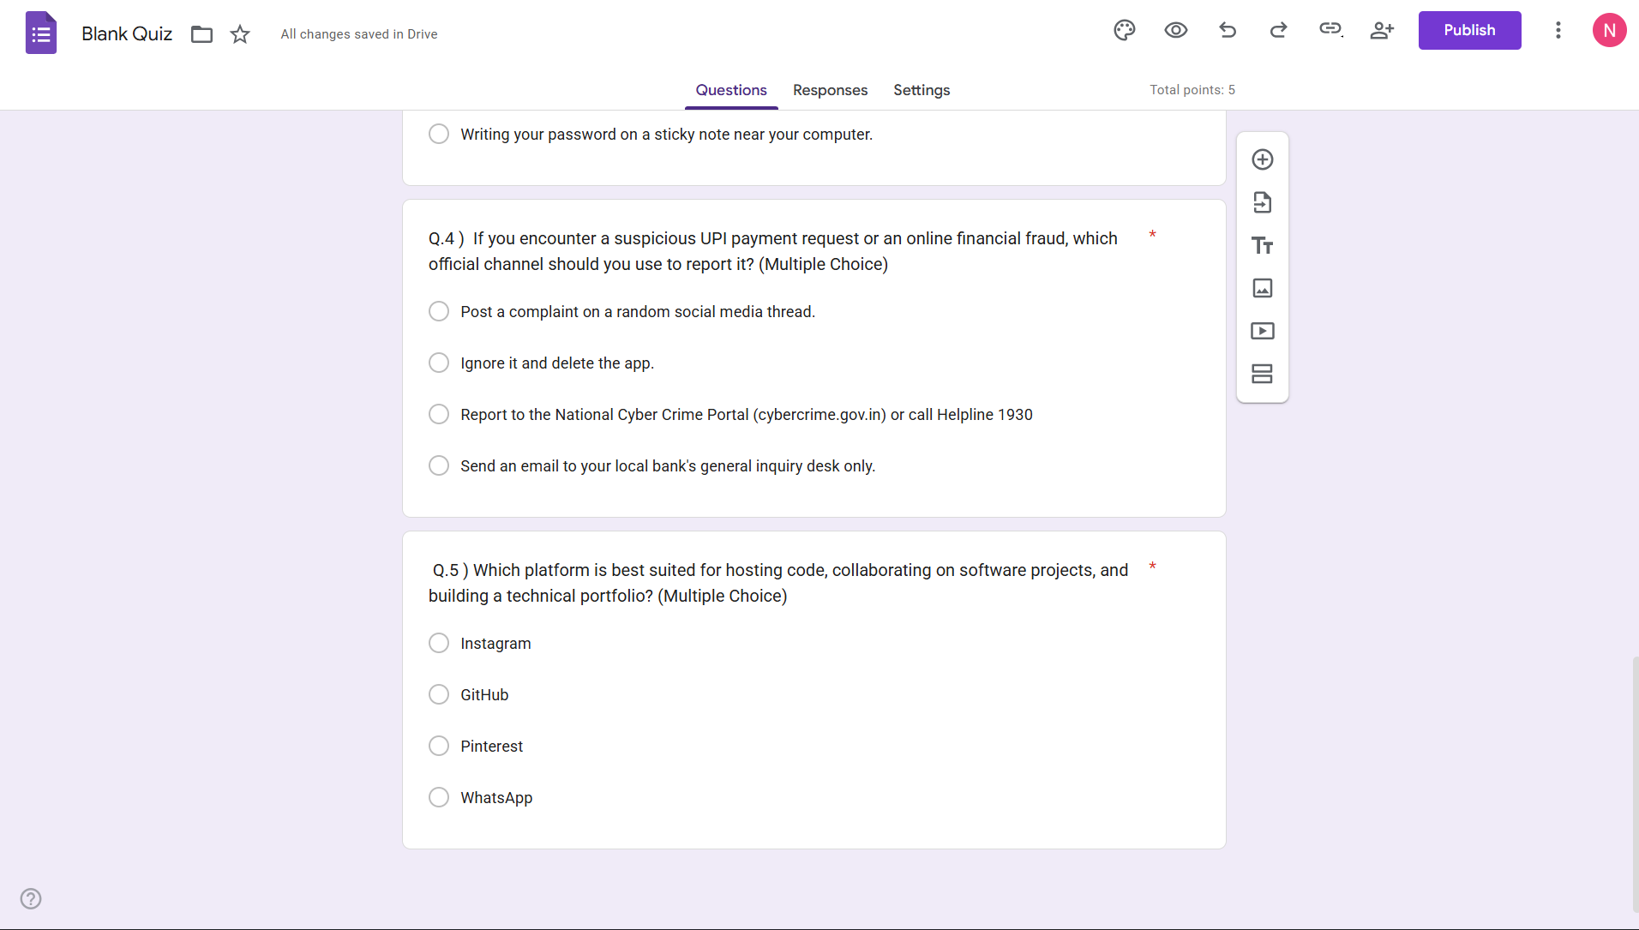

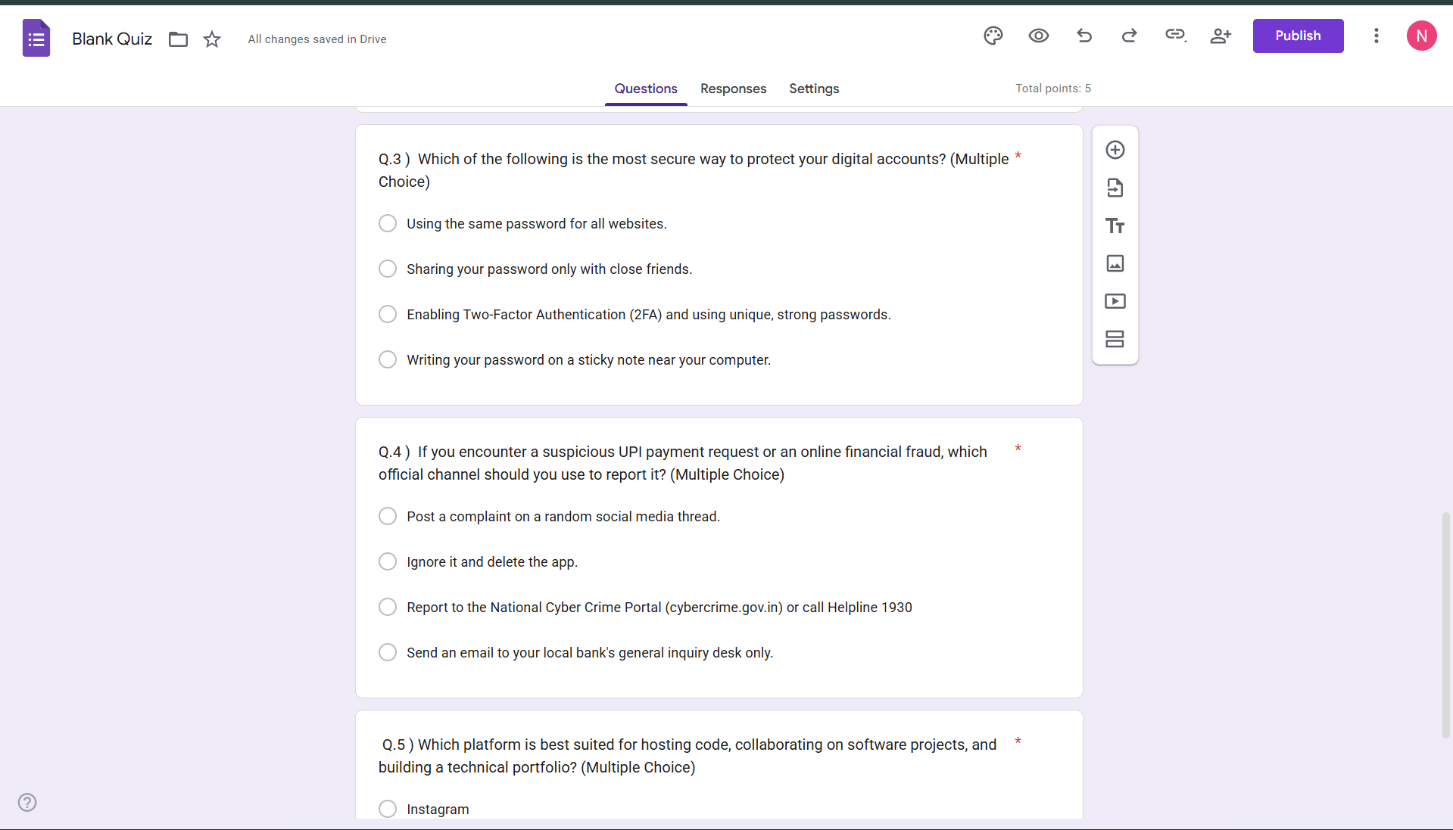
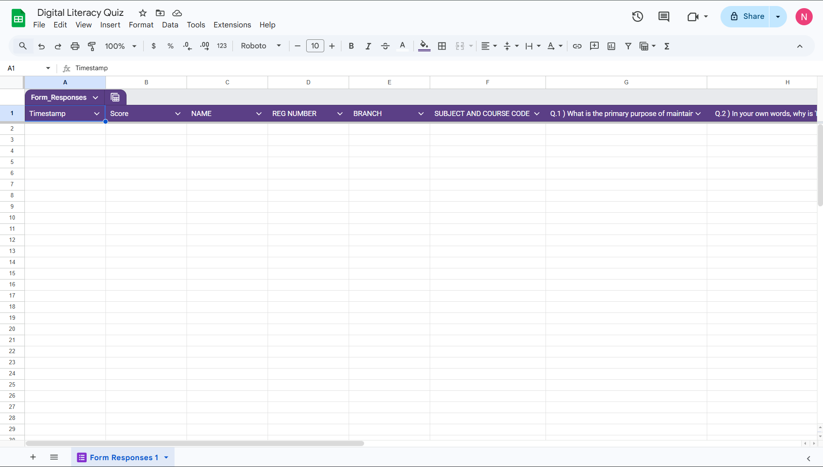

Task 4: Professional Communication
Part A: Draft two emails—one to a professor (deadline extension) and one to an internship coordinator.
Part B: Create a "Social Media Do’s and Don'ts" checklist (5 of each).
Report: Write 100–150 words on a scenario where poor communication caused a problem.

For Task 4, I practiced professional digital communication by drafting formal emails and a social media etiquette guide. One situation where poor digital communication often causes problems is when a student sends an informal, 'text-style' email to a professor without a subject line. This can lead to the email being ignored or marked as spam, causing the student to miss important deadlines.
Through this task, I learned that professional communication is about respect and clarity. By using structured subject lines and formal greetings, I can ensure my message is taken seriously. These skills are not just for college but are essential for my future career in the tech industry, where clear email communication with global teams is a daily requirement

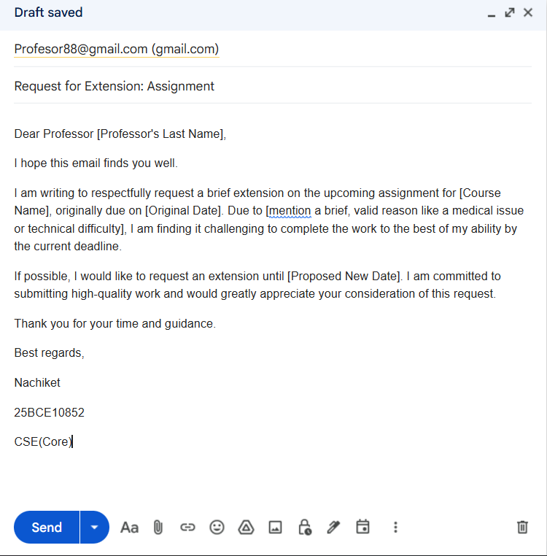
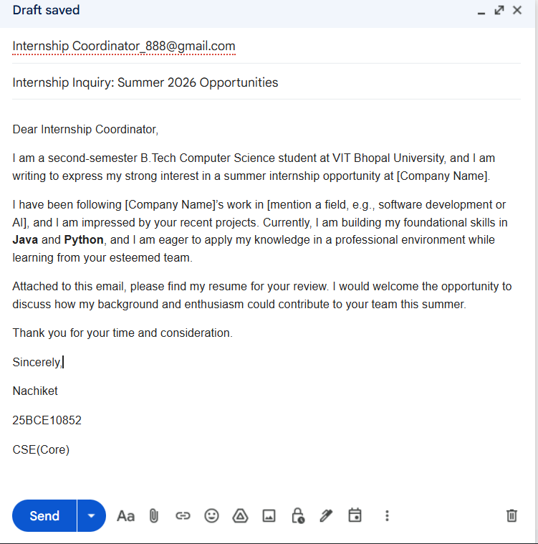

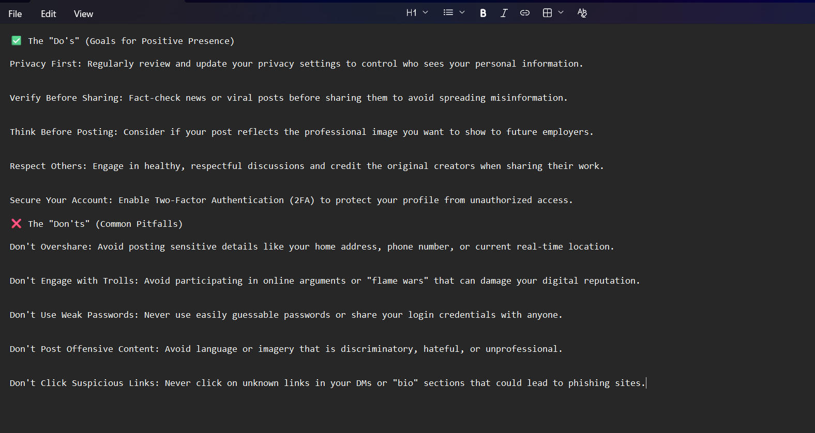
For Task 4, I focused on the importance of professional digital communication by drafting formal emails and a social media etiquette guide. A common scenario where poor communication causes significant problems is when a student sends an informal, 'text-style' email to a professor without a clear subject line or a professional greeting.
In one instance, a student’s request for a deadline extension was automatically filtered into a spam folder because the subject line was blank. By the time the error was realized, the deadline had passed, resulting in a loss of marks. This situation could have been avoided by using a structured subject line and a formal tone, which ensures the message is recognized and treated with priority. This task taught me that clear, respectful communication is not just a soft skill but a critical tool for academic and professional success.

Task 5: Cybercrime Awareness
Part A: Write a 200–250-word case study on a crime like Phishing or UPI Fraud.
Part B: Create a "Stay Safe Online" checklist with 8 tips (2 must be for UPI safety) and include the 1930 helpline.
Report: Write 100–150 words on what surprised you during your research.

Part A: Case Study (File: casestudy.md)
Topic: UPI Payment Fraud via "Request Money" Feature
UPI fraud has become one of the most prevalent cybercrimes targeting college students in India. A common scenario involves a fraudster posing as a buyer on a secondary marketplace like OLX. The criminal contacts a student who is selling an item and expresses immediate interest. Instead of sending money, the fraudster sends a 'Request Money' link through a UPI app like GPay or PhonePe.
The criminal uses social engineering by telling the student, 'I have sent the payment; you just need to enter your PIN to authorize the credit.' Because the student is in a hurry, they often fail to notice that the app is asking them to 'Pay' rather than 'Receive'. Once the PIN is entered, the money is instantly debited from the student's account and moved through multiple dummy accounts to avoid tracking. The consequences are often the total loss of the account balance and significant emotional distress. This crime typically targets young adults who are comfortable with technology but may not be aware of the specific security protocols of UPI transactions, where a PIN is strictly only required for sending money, never for receiving it.

Part B: 'Stay Safe Online' Checklist (File: prevention-checklist.md)
This list includes the mandatory financial tips and reporting channels.
- UPI Safety: Never enter your UPI PIN to receive money; a PIN is only required to send or deduct money.
- UPI Safety: Always verify the merchant or person's name on the screen before hitting the 'Pay' button.
- Use 2FA: Enable Two-Factor Authentication on all your social media and email accounts.
- Check URLs: Always look for 'https://' and the padlock icon before entering credentials on any website.
- Strong Passwords: Use a unique, complex password for every account—never reuse your college portal password for social media.
- Public Wi-Fi: Avoid logging into bank accounts or shopping when connected to free, unsecured public Wi-Fi networks.
- Privacy Settings: Set your social media profiles to 'Private' to prevent strangers from gathering personal data for identity theft.
- Software Updates: Keep your mobile OS and banking apps updated to ensure you have the latest security patches.
TO REPORT A CRIME: * Visit the National Cyber Crime Portal

Report Write-up (100–150 words)
During my research for Task 5, I was most surprised to learn that cybercriminals don't just use technical 'hacking' to steal money; they primarily use psychology and social engineering to trick victims. I discovered that even students with high technical literacy can fall for UPI scams because the fraudsters create a false sense of urgency that causes people to overlook simple warnings.
This realization has led me to personally change my digital habits. I have now committed to pausing and double-checking every transaction request I receive, even if it looks official. I have also saved the 1930 helpline in my contacts and shared it with my peers as part of my Digital Ambassador role. This task highlighted that being safe online is more about constant vigilance and skeptical thinking than just having a secure password.

🎓 Project Conclusion
Completing the Digital Literacy Portfolio has been a transformative experience in my first year at VIT Bhopal. By working through the five modules, I transitioned from a passive user of technology to a responsible Student Digital Ambassador. I have not only built a professional presence on platforms like GitHub and LinkedIn but also gained a deep understanding of cyber safety and professional communication. This project reinforced that digital literacy is a continuous process of learning and adaptation. The skills I have documented here—ranging from cloud collaboration to recognizing UPI fraud—will serve as a strong foundation for my academic success and future career in the technology industry.

📚 References Section
• Canva: Graphic design tool used for Task 1 infographic. [canva.com]
• GitHub: Platform used for hosting the project repository and professional portfolio. [github.com]
• LinkedIn: Professional networking platform used for Task 2. [linkedin.com]
• Kaggle: Data science platform used for Task 2 portfolio. [kaggle.com]
• HackerRank: Coding practice platform used for Task 3 challenge. [hackerrank.com]
• Google Forms & Sheets: Tools used for Task 3 collaboration and data collection. [forms.google.com]
• National Cyber Crime Reporting Portal: Resource for Task 5 cybercrime research.

